“Sweat and tears may look the same, but permit the slave to tell the taste”. – Sir Black (2010)

NAME:
QUAYE, KOJO BENEDICT aka Sir Black
YEAR AND PLACE OF BIRTH:
1978, ACCRA - GHANA
ADDRESS:
P.O. BOX GP 21108 ACCRA NORTH
H/NO. C178/18 ABELENKPE, ACCRA.
ARTISTIC DISCIPLINE:
SPOKEN WORD (EHALAKASA)/PERFORMING ART/PAINTING/SCULPTURE
ARTISTIC SERVICES
PERFORMANCES/COMMISSIONED WORK/WORKSHOPS/MASTER CLASSES/EVENTS
EDUCATION:
LARGELY SELF TAUGHT
STATEMENT:
“Sweat and tears may look the same, but permit the slave to tell the taste”.
PHILOSOPHY:
I’m serving my time, making and unmaking out of life what no one is making out of me.

PROOF OF ARTISTIC TRAINING
From a very humble beginning with no particular formal education in the arts, he through observation and self encouragement with determination created some works that caught the attention of Cultural officer of Alliance Française, Accra to grant him the opportunity and space for what can be described at the time as his maiden appearance/exhibition of paintings, sculptures and performances. He did a few free style performances at the opening which was later described to him as spoken word poetry and from that day on, he has not looked back at performance poetry. He later discovered that he had earlier before this time been doing what was also known to be Dawn Broadcasting an early morning preaching in neighborhoods and communities which he believe help shape his oratory into performance poetry.

Between 1995 and 1998, and then somewhere between2001and 2005 he was invited to do motivational talks in local schools and communities in some selected township in Accra our nation capital and surrounding areas. He can confidently say all of these contributed to his development into performance poetry today.

Performance poetry was not popular at the time when he appeared on the scene nevertheless there were few poets or people who have published their poems yet never been seen doing their poetry publicly. With hope and persistence over the years he has work earnestly with few friends to raise the awareness and the need for recognition to this beautiful art form called spoken word poetry performance. He is the sole brain behind all the Ehalakasa projects and events to be mention later below. For authenticity and access to school and communities he registered his own event enterprise under which he organizes all the school projects and events called G3 Channels operating for nonprofit. He has been commissioned to work on several events, projects and programs mostly on the creative arts and spoken word poetry domain. His contribution and achievement to the development of Ghana’s creative and cultural landscape is evident in the only regular monthly event “Ehalakasa Talk Party” he the host which has been running since 2008. It is wealth stating that Spoken word poetry performance in Ghana is called EHALAKASA and the respond is it Lives in Us!

PREVIOUS ARTISTIC WORKS
EHALAKASA is a concept created by Sir Black and musician/poet Nii Lantey in 2007, simply to bring poetry from the page to the stage. The basic Intent for Ehalakasa is to address and deal with issues relevant to our time as a people, whiles projecting Ghanaian values. EHALAKASA is a straight talk, street philosophy poetry and music performance. Eha means Song in Ewe, La means Sing in Ga Dangbe and Kasa means Talk in Akan (Twi). These separate words are simply combined to form EHALAKASA; and the response is: "It lives in us".
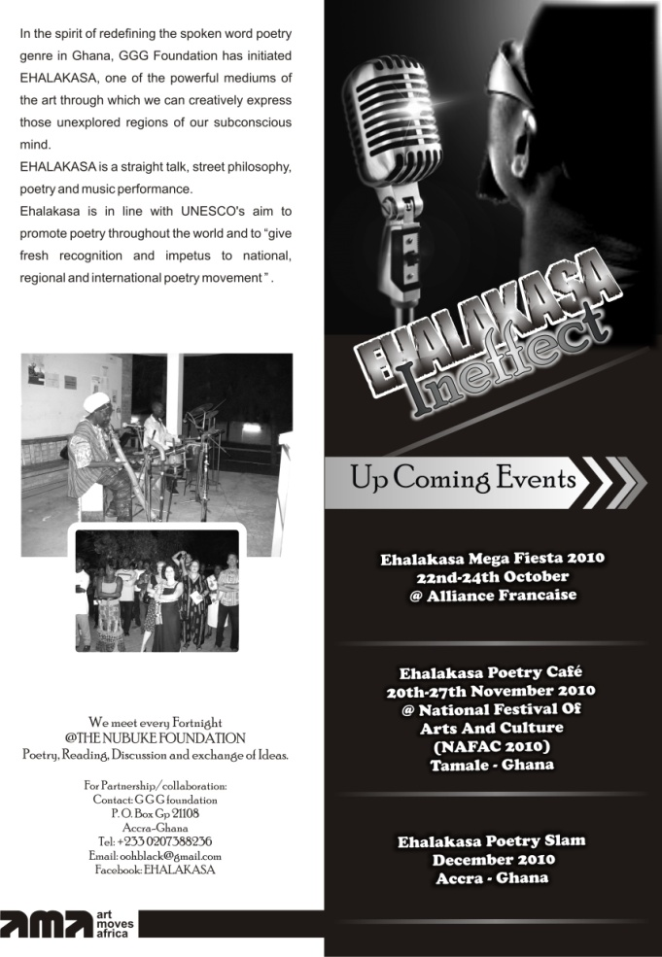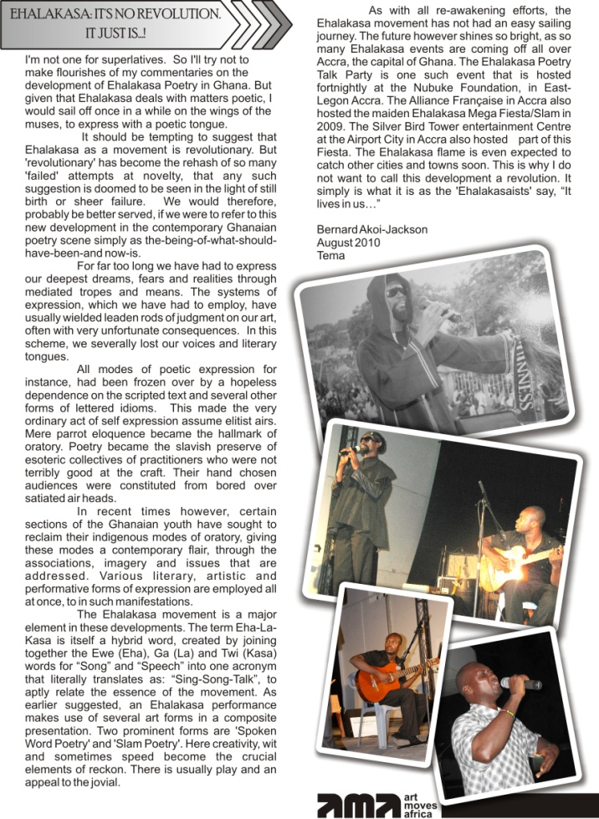

EHALAKASA has evolved out of the response to art lovers' (poets/general public) desire for the awakening and recognition of spoken word performance poetry in Accra and Ghana. The past years has been highly successful with projects and events like, Ehalakasa Slam, Ehalakasa Talk Party, the annual Ehalakasa Int. Poetry Day, Ehalakasa in Senior High Schools (workshops), Ehalakasa @ NAFAC, Ehalakasa Flash Mob, Ehalakasa Fiesta, Ehalakasa Mega Fest and now Ehalakasa Festival etc. These events were organized in collaboration with Alliance Francaise, Goethe Institut, Nubuke Foundation, Writers Project of Ghana, Ghana Association of Writers, Cultural Education Unit of Ghana Education Service, Ghana Culture Forum etc. The sole coordinator and event organizer is Sir Black.
Currently he is also working on what he calls TalkFACT3 Project, a solo touring performance and workshop series in schools and communities mainly to “edutain” (educate and entertain) through the use of words.

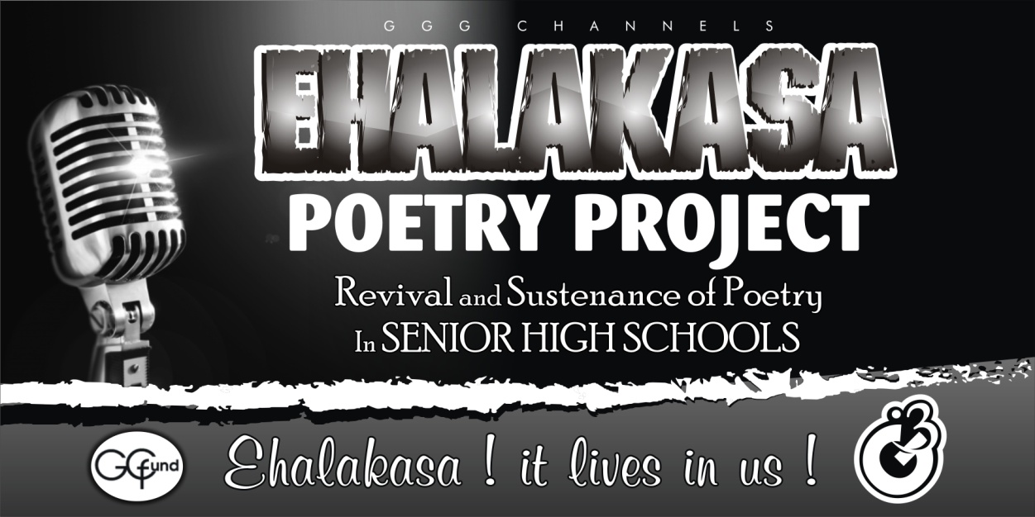

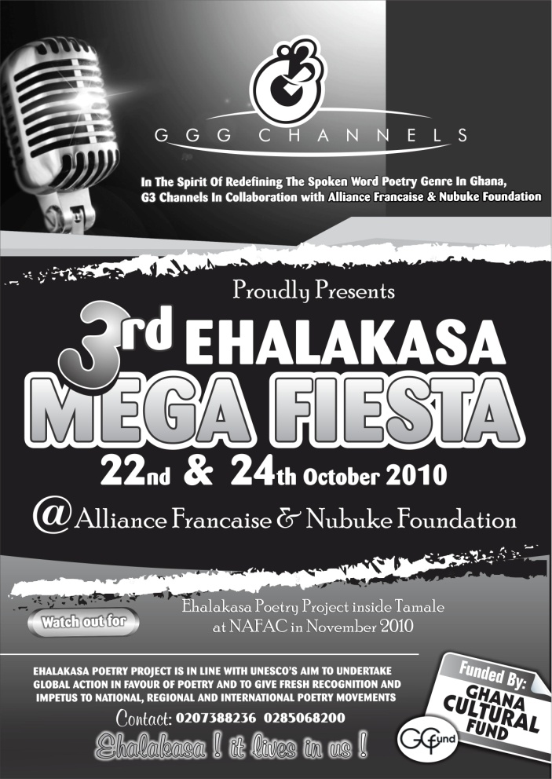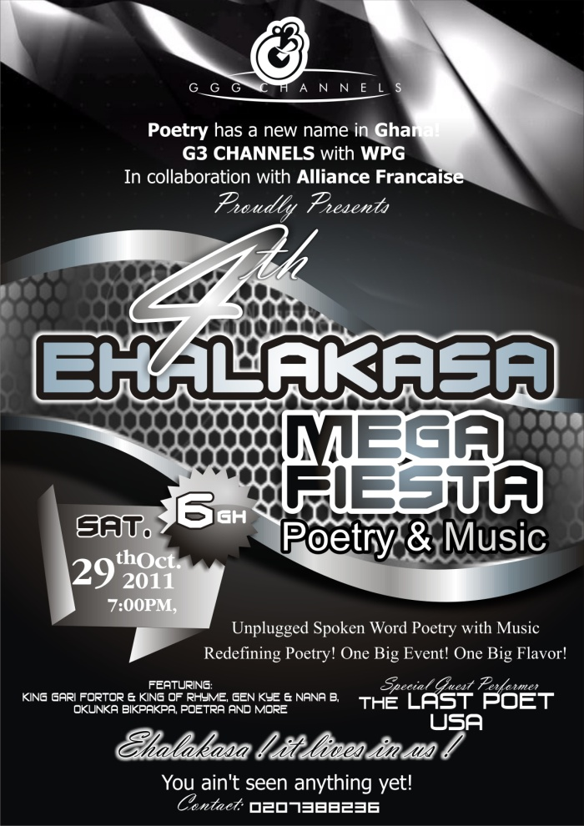

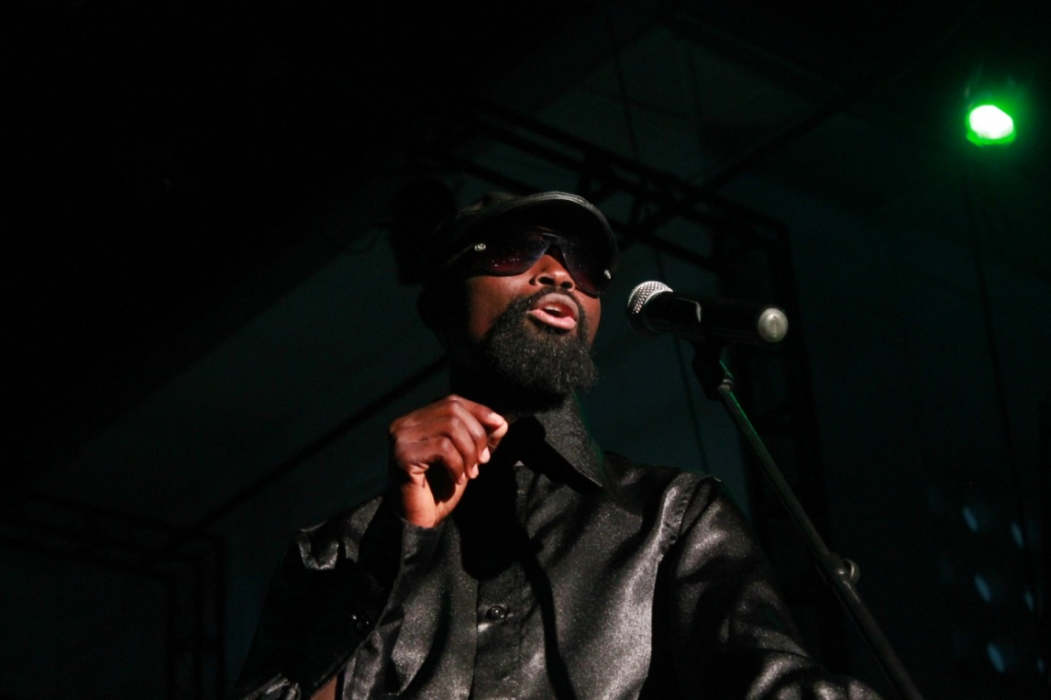
@ Sir Black performing at a recent show, Alliance Francaise

PREVIOUS WORK I
A Tapestry of African Experience is touring project based on the anthology of poems by different African poets which was staged and performed live by veteran Actor, Poet, and Playwright EVANS OMA HUNTER and young dynamic poet Ehalakasa performer QUAYE KOJO BENEDICT aka Sir Black.
The show which is expected to tour selected schools and countries will feature not only poetry by Oma & Black but music, dance and an extract from the New Patriot by Sarif Easmon. A moment where the old poets meet the young contemporary poets to share experience for the benefit of the up and coming youth to learn from the works of the old folks. We believe it is important to let this interaction take place between the old and the young poets in a performance to experience the development that has arrive since poetry became prominent in Africa.
We intend to present works of poets that have come and pass, some of who are still with us but almost forgotten and the works of those emerging contemporary poets for the appreciation of our present audience particularly the youth. We believe this initiative is an essential part to the development of our nation’s cultural landscape; in bridging the gap between the older poets and the young poets.
A tapestry of African experience feature and presented selected works written by Africans including Leopold Sedar Sengor, Dr Efua Surtherland, Geormbeeyi Addali-motty, Prof Kofi Awoonor, Frank Kobena Parks, Prof. Ayikwei Armah, Prof. Wole Soyinka, Valantino Malangatana, Prof. Atukwei Okai and Sarif Easmon and presented by veteran Ghanaian performer and a dynamic young poet who is making tremendous strides in the area of poetry performance in the country.
The maiden edition of The Tapestry of African Experience was held at the Alliance Francaise in Accra. The event brought together a cross section of people from writers, actors, cultural workers; politicians and students were audience that graced the event.

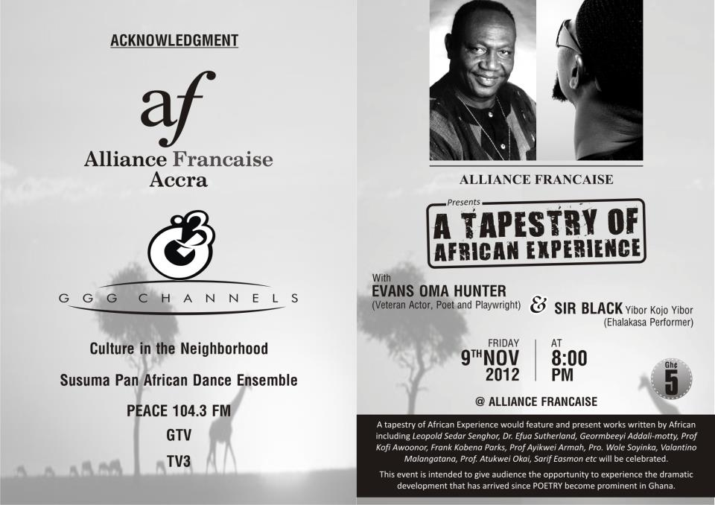

Below are images from The Tapestry of African Experience.

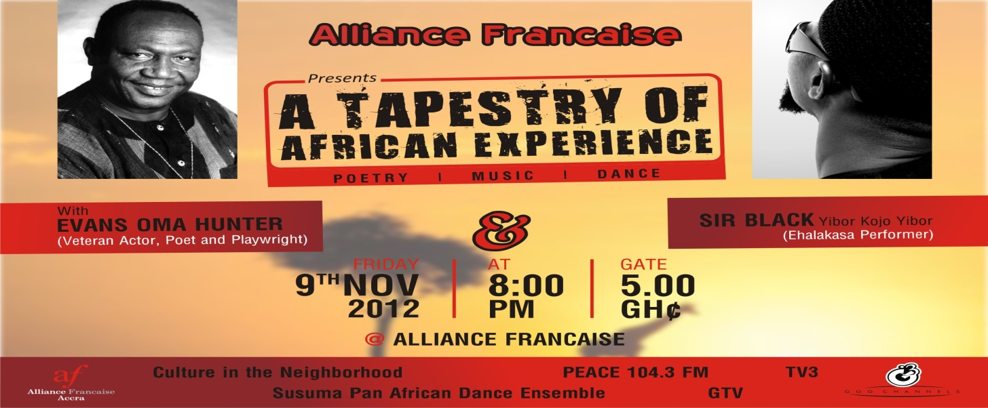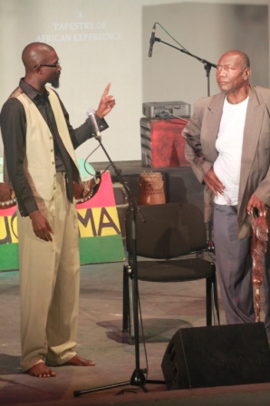Sir Black with Oma Hunter
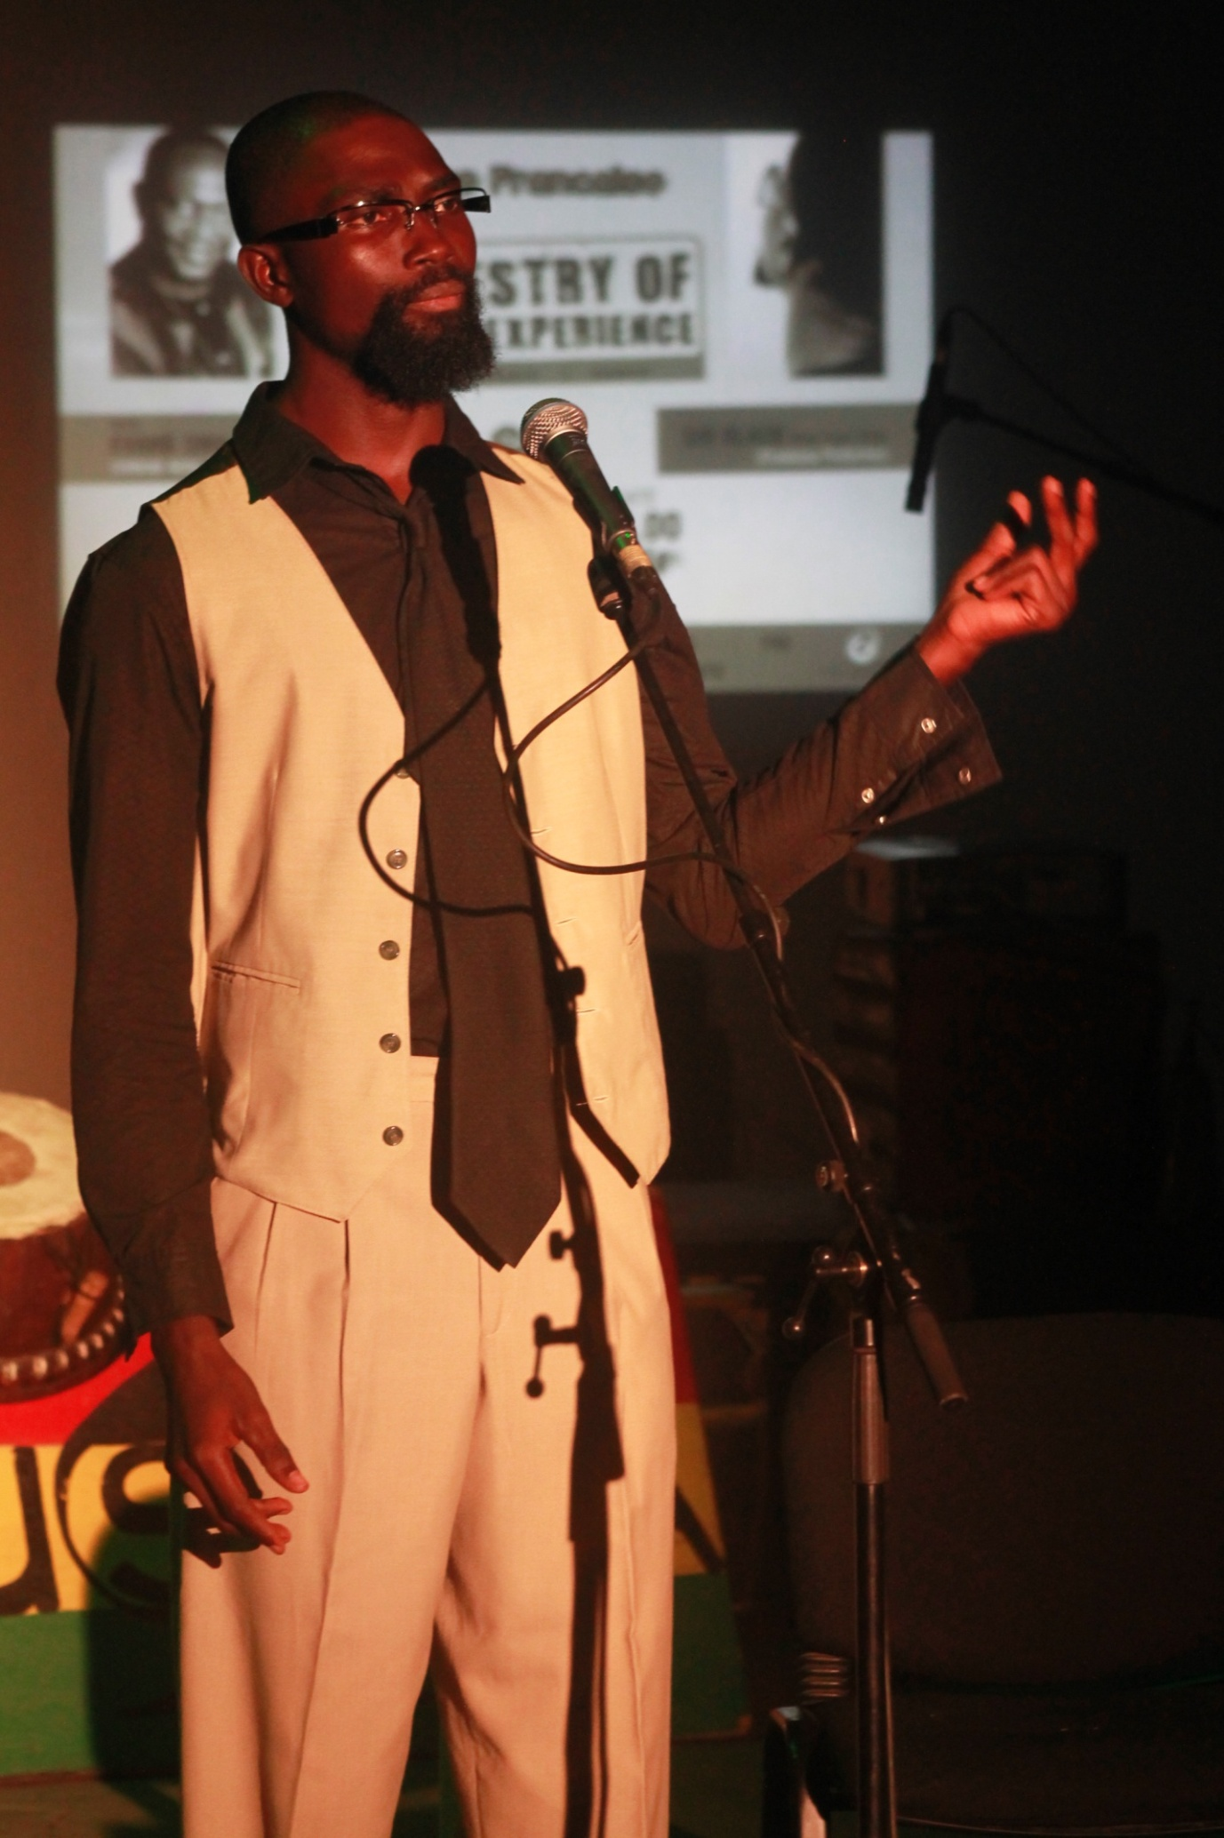
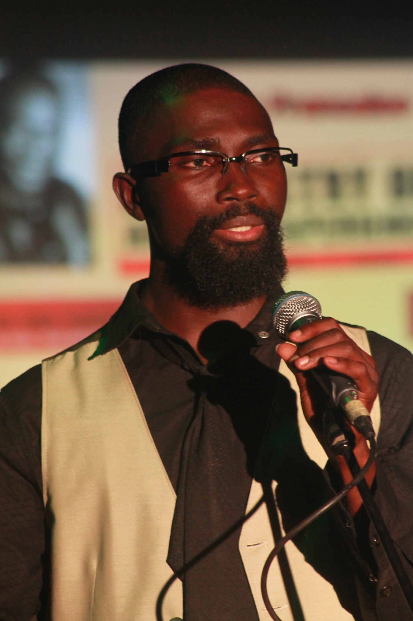
PREVIOUS WORK II

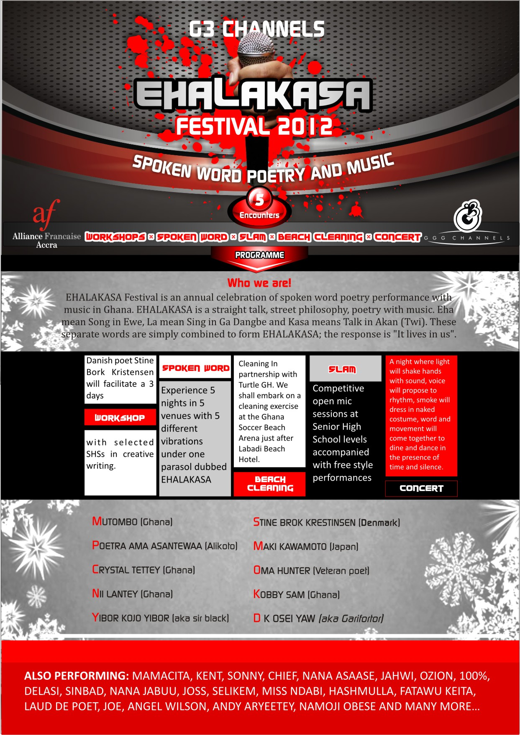
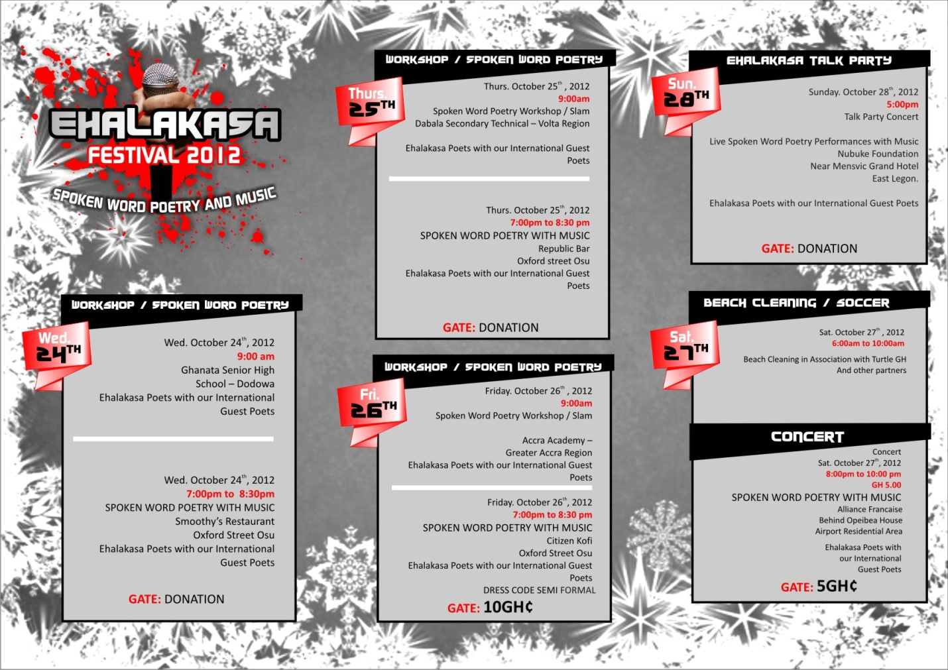
Below are some related links:
http://www.afaccra.com/index.php?view=details&id=108%3A5thehalakasa&option=com_eventlist&Itemid=111&lang=fr
http://www.dailyguideghana.com/?p=64149
http://wangoweb.com/2012/10/19/ehalakasa-poetry-festival-at-the-alliance-francaise-on-oct-27/

Sir Black over the years manages to coordinate events and still perform with such exuberance. He has come to accept the fact that it is not over until it is over, thus he is able to generate such an unusual ability to see through the event right from conception to delivery where audience will walk away after each show smiling and full cheer, this brings him satisfaction.
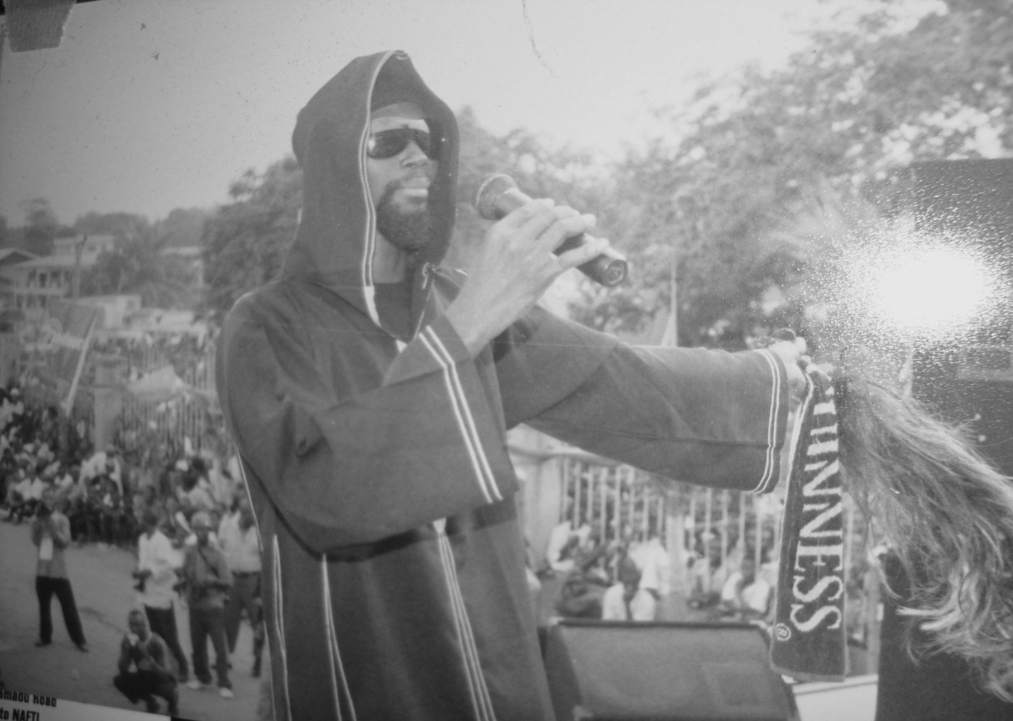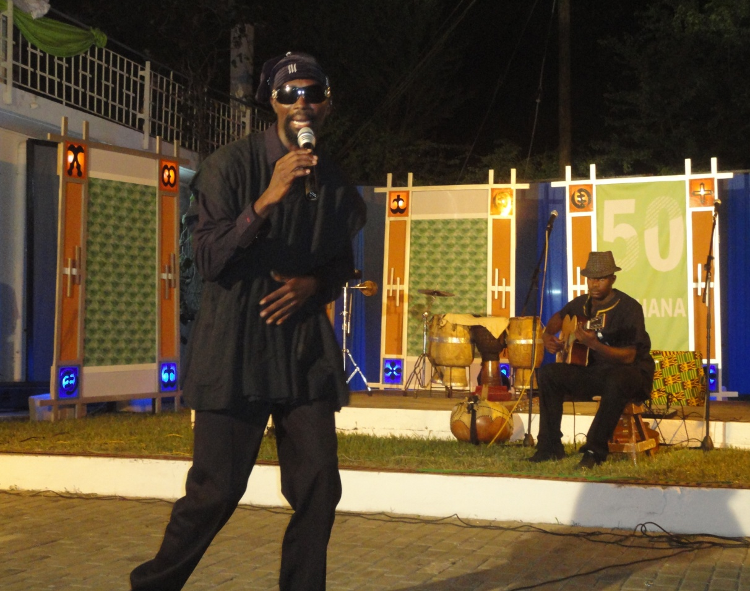
Above: Sir Black performing at a concert
Below: Sir Black Performing at Goethe Institut @ 50 in Ghana
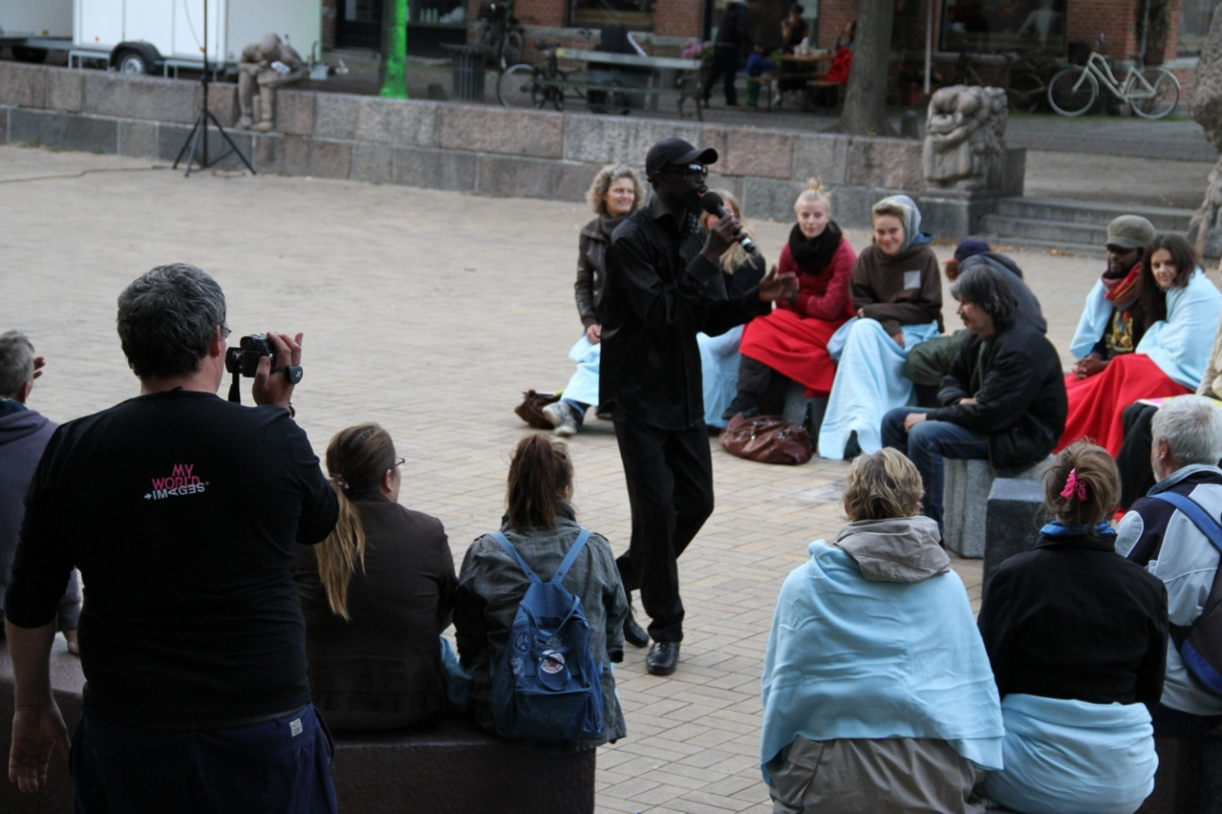Sir Black performing at an open air theatre in Copenhagen, Denmark
PUBLISHED WORKS

Title: Will you also chop some and go?

When an African (one of my lot) becomes president two things are sure
If he came by the ballot box
Hallelujah, the people sing, new Messiah
We put you here to serve us, he reply your vote is the power
But in his heart,
Well this is my chance let me chop some and go

On the other hand
If he came by the gun
Boy o boy, the people cry in agony
He replies, I came here by my self
You obey you live, you disobey you die
By the way everything will be okay
But in his heart, let me also chop some and go

In the final analysis
Colonization, militancy, autocracy, democracy, nothingcracy
We know them, what next?
Will you also chop some and go when you become president?

- Published in EHALAKASA Poetry Volume 1 by Woeli Publishing service, Accra Ghana 2011
- Published in ARTFOCUS a publication of Nubuke Foundation

